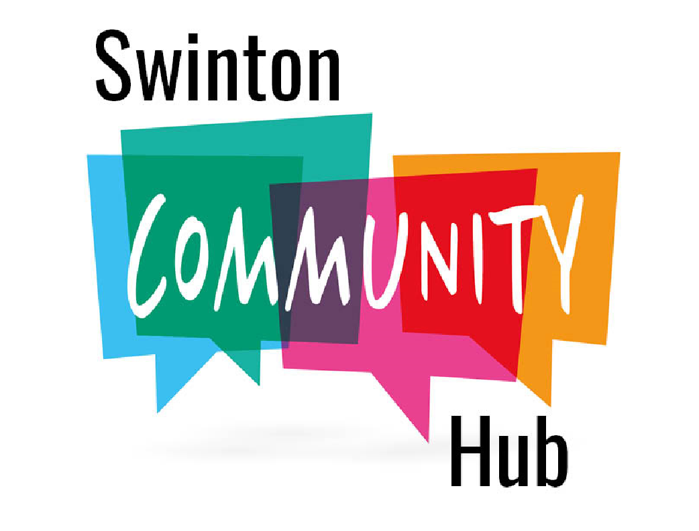
#No.7

NEWS
Letter

IT’S GOOD NEWS!
It is nice for a change to be able to report some good news in a world which is beset by continual gloom and doom. Not just one piece of good news but two. Firstly, Swinton Community Hub’s Stage 1 Application to the Scottish Land Fund for funding to purchase Swint0n Kirk has been approved which means we can now move to Stage 2 when we will have a definitive yes or no as to whether we will be awarded the money to buy the church. The timeline is extremely tight as applications must be submitted by the 18th of August, at which point the fund will close. There is no guarantee that the fund will reopen as there may be a change of administration following the Holyrood Election in 2026., so it is vital that we meet the deadline. Whilst most of our bid is in place we must develop a Five-Year Business Plan to demonstrate the long-term viability of the Community Hub and to that end we have the support of Community Ownership Services Scotland and South of Scotland Enterprise.
The second bit of good news is that we have had a Roof Survey carried out on the building and we are pleased to confirm that the roof is in good condition and will only require some £3,200 of remedial work. The only exception is the Vestry/Kitchen extension which will require replacement and which we have allowed for in our development costings. In addition to our bid for funding to purchase the church, we can also include the cost of the roof remedial work and all our legal costs.
With regard to the long-term viability of the Hub your committee realise that purely running the Hub as another Village Hall is unsustainable and so our plans include a state of the art cinema, which will run at least three nights a week, but our overall vision is to develop the venue as a Cultural/Entertainment Centre which puts the community at its very heart. In addition to providing a safe and open meeting space for all, irrespective of gender, ethnicity, creed and culture, we would hope to build Swinton Community Hub as a premier rural cinema, music and arts venue, working with organisations such as Creative Scotland to bring Theatre, Music, Dance and Storytelling to Swinton, Berwickshire and beyond. We envisage workshops for our youngsters led by the best of talent. All this will be driven by our Media and Marketing Plan and delivered mainly through social media.
The community and people of Sinton will be at the heart of the Hub and individuals, groups and charities will be afforded priority with regards to bookings for all events and with your support we hope to develop a welcoming and flexible community space.
This we hope will sustain the Hub for years to come, in order that we can advance our central mission of serving the community.
COFFEE MORNING
Meet your friends and make new ones at our Coffee morning on Saturday 23rd August at 10.00-12.00 in Swinton Kirk with entry by donation. Enjoy relaxing with Coffee or Tea, Home Baking without having to drive out of the village. Offers of help and donations for the raffle are most welcome. IF YOU WOULD LIKE TO HELP, Contact us by email at swintonhub@gmail.com
Raffle prizes can be left in the church or handed to any committee member.

MEMBERSHIP
Why not sign up now to membership of the Hub and take the opportunity to let us know what facilities and events you would like to see at the Hub. Membership is free and open to all residents over the age of 16. Fill in the membership form below and leave it in the box below, or if you would prefer to do it on line, send us an email at swintonhub@gmail.com Copies are also available in Swinton Church. If you do not live within the immediate Swinton area, associate membership is available.
We would ilike nvite you to join our committee or we are looking for volunteers with commercial, financial or cultural experience to help drive our project forward.
WHO WE ARE
Our four Trustees are: David Dalglish (Chair), Leslie Findley (Secretary), Mark Stepheson, Barry Symes (Treasurer).
Your committee is Tom Baird, Stephen Brewer, Jocelyn Davies Edwards, Tim Morris, Nick Parker, Bill Purvis, Meg Reid, Janet Starkey.
Our thanks to Hazel Parker who has decided to resign from the committee for all her efforts in making sure this newsletter was delivered to every house in the village.

SUPPORTED BY THE ARCHITECTURAL HERITAGE FUND

Swinton Community Hub SCIO Scottish Charity SC052998

We need your consent to send you communications. You can give consent by filling in this form and ticking the boxes at the foot of the page. If possible we would prefer to contact you by email in order to reduce administrative costs.
SWINTON COMMUNITY HUB SCIO
Membership Form

In Swinton Kirk - Contact Details

Identification |  |  | Please tell us who you are
Surname
Christian Names
Location |  |  | Please enter your (full or partial) postcode, so as to help us know your location.  Only enter your full address if you agree to us sending you postal communications.
Postcode
Contact details |  |  | Please give us details of how we may contact you.  Only fill in the address and/or number(s) that you agree to us using to contact you.
Postal address
Email address
Telephone number (home)
Telephone number (mobile)
We may use this for text messages.

Which types of communication do you wish to receive?
Please tick all that apply
“Hub Newsletters” by email |  | Paper copy of “Hub” Newsletters by post |  |  | News of Hub events and other information about The Hub |  | Invitations to help with the running of the Hub
Your contact details and preferences will be stored on the Merse Church database.
Please submit either or both parts of this form to: Mark Stephenson via email or post (see below)
Database Administrator (Swinton Community Hub SCIO)
Email: 11dmsmark@gmail.com
Address:
No. 3, Swinton Bridge End Farm Cottage,
Duns, TD11 3HY. Scottish Charity SC052998
Your details will be stored in accordance with the current GDPR Regulations and can only be accessed by the Administrator
THE MERSE CHURCH
THE MERSE CHURCH an interdenominational church which welcomes all who acknowledge Jesus Christ as their saviour and those who are seeking, is presently one of our regular users of the building and meets every third Sunday of the month for worship and fellowship and refreshment at 10.00. From Sunday 5th October they will also meet on the 1st Sunday of the month at 10.00 for Celtic Communion.
For your diary our services for the rest of the year are as follows:
Sunday 20th July Morning Worship at 10.00 led by Reverend Duncan McCosh
Sunday 17th August at 10.00 Communion with Revend Robin McHaffie
Sunday 21st September at 10.00 Morning Worship
Sunday 5th October at 10.00 Celtic Communion
Sunday 19th October at 10.00 Harvest Festival
Sunday 2nd November at 10.00 Celtic Communion
Sunday 9th November at 11.15 Remembrance Day
Sunday 16th November at 10.00 Preparing for Advent
Sunday 7th December at 10.00 Celtic Communion
Sunday 21st December at 10.00 Carol Service
Thursday 25th December at 10.00 Christmas Family Service

.

